Business Report

Health Care Capstone Project
By
Rajesh Mambulli

Table of Contents
Health Care Capstone Project 1
1. Business Problem 6
2. Goal & Objective 6
3. Data Dictionary 6
4. Data Overview through Python 7
4.1 Checking and Treating Missing values in the data 9
4.2 Checking for duplicate values in the data. 9
4.3 Checking the statistical summary of the data. 10
5.0 Missing Value Imputation 11
5.1 Missing values after Imputation 12
6.0 Checking for Outliers 13
6.1 Feature Engineering 13
7.0 Exploratory Data Analysis 15
7.1 Univariate Analysis 15
7.2 Bivariate Analysis 26
8.0 Clustering 41
9.0 Cluster Profiling Conclusions 44
10.0 Data Preparation for Modelling 45
11.0 Model Building 46
12.1 Parametric Models 48
12.2 Non-Parametric Models 56
12.4 Feature Importance of Tuned Random Forest Model 65
12.5 Feature Importance of Tuned XG Boost Model 66
13.0 Interpretation of the Most Optimum model 66
14.0 Validation Approach 67
15.0 Insights and Recommendations 68

Table of Figures
Figure 1: Data Head 7
Figure 2: Data Tail 7
Figure 3: Data Types 8
Figure 4: Missing data 9
Figure 5: Statistical Data summary 10
Figure 6: Missing data after imputation 12
Figure 7: Outliers in data 13
Figure 8: years_of_insurance_with_us 15
Figure 9: regular_checkup_lasy_year 15
Figure 10: adventure_sports 16
Figure 11: Occupation 16
Figure 12: visited_doctor_last_1_year 17
Figure 13: cholesterol_level 17
Figure 14: daily_avg_steps 18
Figure 15: Age 18
Figure 16: heart_decs_history 19
Figure 17: other_major_decs_history 19
Figure 18: Gender 20
Figure 19: avg_glucose_level 20
Figure 20: Bmi 21
Figure 21: smoking_status 21
Figure 22: Location 22
Figure 23: Weight 22
Figure 24: covered_by_any_other_company 23
Figure 25: Alcohol 23
Figure 26: Exercise 24
Figure 27: fat_percentage 24
Figure 28: insurance_cost 25
Figure 29: Heat Map 26
Figure 30: mean insurance_cost vs regular_checkup_lasy_year 28
Figure 31: mean insurance_cost vs adventure_sports 29
Figure 32: mean insurance_cost vs Occupation 30
Figure 33: mean insurance_cost vs cholesterol_level 31
Figure 34: insurance_cost vs daily_avg_steps 32
Figure 35: insurance_cost vs heart_decs_history 33
Figure 36: insurance_cost vs other_major_decs_history 33
Figure 37: insurance_cost vs Gender 34
Figure 38: insurance_cost vs avg_glucose_level 35
Figure 39: insurance_cost vs bmi 36
Figure 40: insurance_cost vs smoking_status 37
Figure 41: insurance_cost vs Alcohol 38
Figure 42: insurance_cost vs exercise 38
Figure 43: insurance_cost vs fat_percentage 39
Figure 44: RFE Model Top Features 41
Figure 45: K Means Clustering 41
Figure 46: K Means Clustering 42
Figure 47: K Means Clustering 42
Figure 48: K Means Clustering 43
Figure 49: K Means Clustering 43
Figure 50: K Means Clustering 44
Figure 51: K Means Clustering 44
Figure 52: Model Split Summary 45
Figure 53: Model Summary 48
Figure 55: Model Summary 48
Figure 56: VIF Summary 49
Figure 57: Predicted values 50
Figure 58: Residual Chart 50
Figure 59: Normality of Residuals 51
Figure 60: Q-Q Plot 51
Figure 61: F-Statistic 52
Figure 62: Model Summary 52
Figure 63: Model Coefficients 52
Figure 64: Model Summary 53
Figure 65: Model Summary 53
Figure 66: Model Coefficients 53
Figure 67: Model Summary 53
Figure 68: Model Summary 54
Figure 69: Model Coefficients 54
Figure 70: Model Summary 55
Figure 71: Model Summary 55
Figure 72: Model Summary 55
Figure 73: Model Summary 56
Figure 74: Data Split 56
Figure 75: Model Summary 57
Figure 76:Model Summary 58
Figure 77: Model Summary 59
Figure 78: Model Summary 59
Figure 79: Model Summary 60
Figure 80: Model Summary 60
Figure 81: Model Summary 61
Figure 82: Model Summary 61
Figure 83: Model Summary 62
Figure 84: Model Summary 62
Figure 85: Model Summary 63
Figure 86: Model Summary 63
Figure 87: Model Summary 64

Business Problem
We all know that Health care is very important domain in the market. It is directly linked with the life of the individual; hence we must be always be proactive in this domain. Money plays a major role in this domain, because sometime treatment becomes super costly and if any individual is not covered under the insurance, then it will become a tough financial situation for that individual. The companies in the medical insurance also want to reduce their risk by optimizing the insurance cost, because we all know a healthy body is in the hand of the individual only. If individual eat healthy and do proper exercise the chance of getting ill is drastically reduced.

Goal & Objective
The objective of this exercise is to build a model, using data that provide the optimum insurance cost for an individual. You must use the health and habit related parameters for the estimated cost of insurance

Data Dictionary
- applicant_id: Applicant unique ID
- years_of_insurance_with_us: Since how many years customer is taking policy from the same company only
- regular_checkup_lasy_year: Number of times customers has done the regular health check-up in last one year
- adventure_sports: Customer is involved with adventure sports like climbing, diving etc.
- Occupation: Occupation of the customer
- visited_doctor_last_1_year: Number of times customer has visited doctor in last one year
- Cholesterol_level: Cholesterol level of the customers while applying for insurance
- daily_avg_steps: Average daily steps walked by customers
- age: Age of the customer
- heart_decs_history: Any past heart diseases
- other_major_decs_history: Any past major diseases apart from heart like any operation
- Gender: Gender of the customer
- avg_glucose_level: Average glucose level of the customer while applying the insurance
- bmi: BMI of the customer while applying the insurance
- smoking_status: Smoking status of the customer
- Year_last_admitted: When customer have been admitted in the hospital last time
- Location: Location of the hospital
- weight: Weight of the customer
- covered_by_any_other_company: Customer is covered from any other insurance company
- Alcohol: Alcohol consumption status of the customer
- exercise: Regular exercise status of the customer
- weight_change_in_last_one_year: How much variation has been seen in the weight of the customer in last year
- fat_percentage: Fat percentage of the customer while applying the insurance
- insurance_cost: Total Insurance cost

Data Overview through Python
Data which is stored in csv file is imported to Jupyter Notebook with the help of pandas, NumPy libraries and used matplotlib and seaborn libraries to help with data visualization. Dataset is stored in python variable named data.
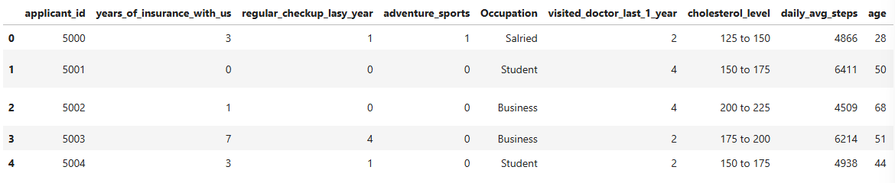
Figure 1: Data Head
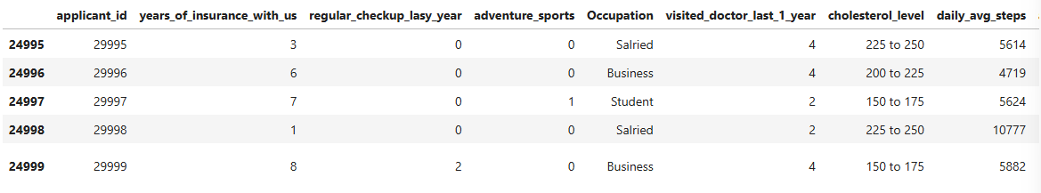
Figure 2: Data Tail
The dataset has 25000 rows and 24 columns.
Checking the data types of data.
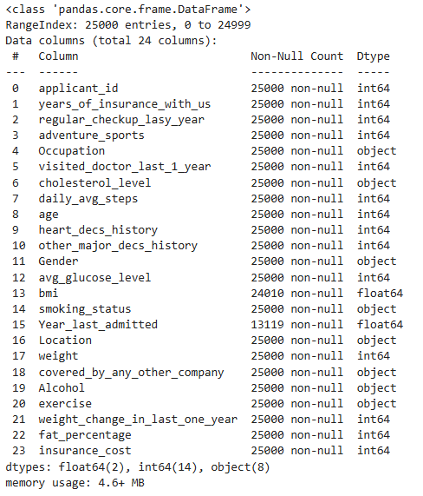
Figure 3: Data Types

Checking and Treating Missing values in the data
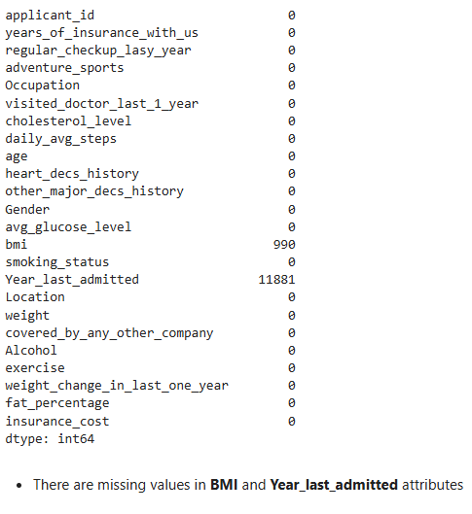
Figure 4: Missing data

Checking for duplicate values in the data.
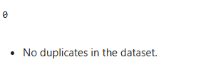
Dropping applicant_id attribute as it doesnot contribute any value to in Data understanding stage

Checking the statistical summary of the data.
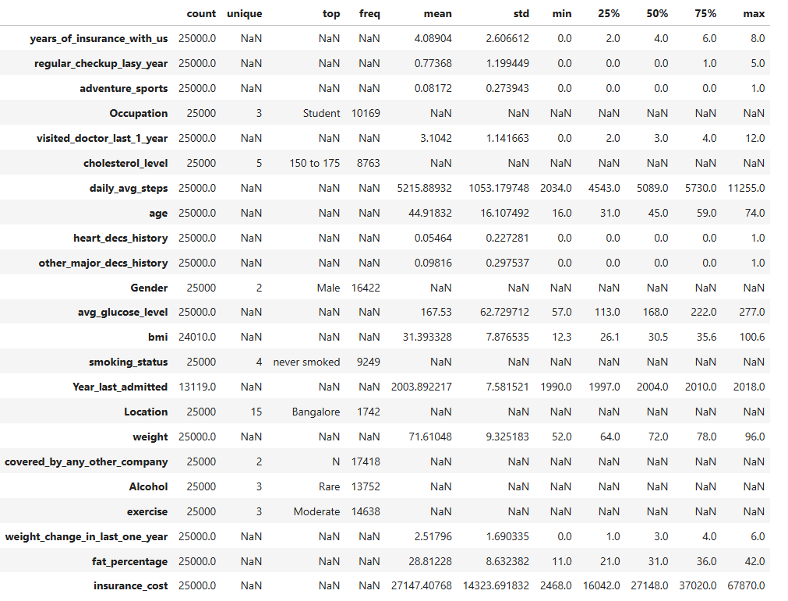
Figure 5: Statistical Data summary
Observations:
years_of_insurance_with_us: Mean ~4 years. Indicates moderate loyalty. Longer duration means more loyalty
regular_checkup_lasy_year: Mean ~1.9 checkups. Reflects moderate proactive care; higher values may indicate stronger health engagement.
visited_doctor_last_1_year: Avg ~3.1 visits. Signals potential existing health concerns or better monitoring.
Cholesterol_level: Most frequent range: 150–175 mg/dL. Mid-range.
daily_avg_steps: Mean ~5,216. Moderately active.
age: Mean ~45 years.
Gender: Male majority.
avg_glucose_level: Mean ~168. High average—potential risk indicator for diabetes, affects premium calculation.
bmi: Mean ~31.4.
smoking_status: Dominated by “never smoked”.
Location: Could reflect regional cost variation.
weight: Mean ~84 kg.
covered_by_any_other_company: Mostly “No”
Alcohol: “Rare” is dominant. Low-risk group; could adjust pricing minimally based on category.
exercise: “Moderate” dominates. Positive lifestyle indicator—linked to reduced claims risk.
weight_change_in_last_one_year: Avg ~2.9 kg. Could indicate lifestyle change, recovery, or instability.
fat_percentage: Mean ~28.8%. Higher fat% aligns with elevated BMI—signals cardio-metabolic risk.
insurance_cost: Mean ~₹27,147.

5.0 Missing Value Imputation
- BMI
Imputing Mean value for the Group of Gender, Exercise, Age
- Year_last_admitted
The idea behind Year Last Admitted is to define what counts as a recent hospital admission.
Engineering this feature to Recent Admission would Flag admissions within certain Range like 2 or 3 years as clinically relevant.
But that again depends on assumption that missing values in this feature as never admitted which in turn makes this feature very synthetic.
Dropping this feature makes more sense.
- applicant_id
Dropping applicant_id attribute as it doesnot contribute any value to in Data understanding stage

Missing values after Imputation
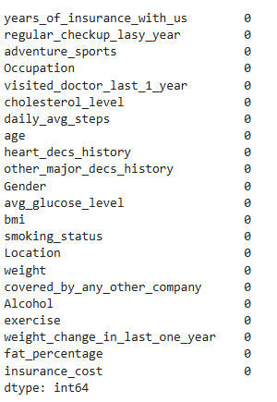
Figure 6: Missing data after imputation

Checking for Outliers
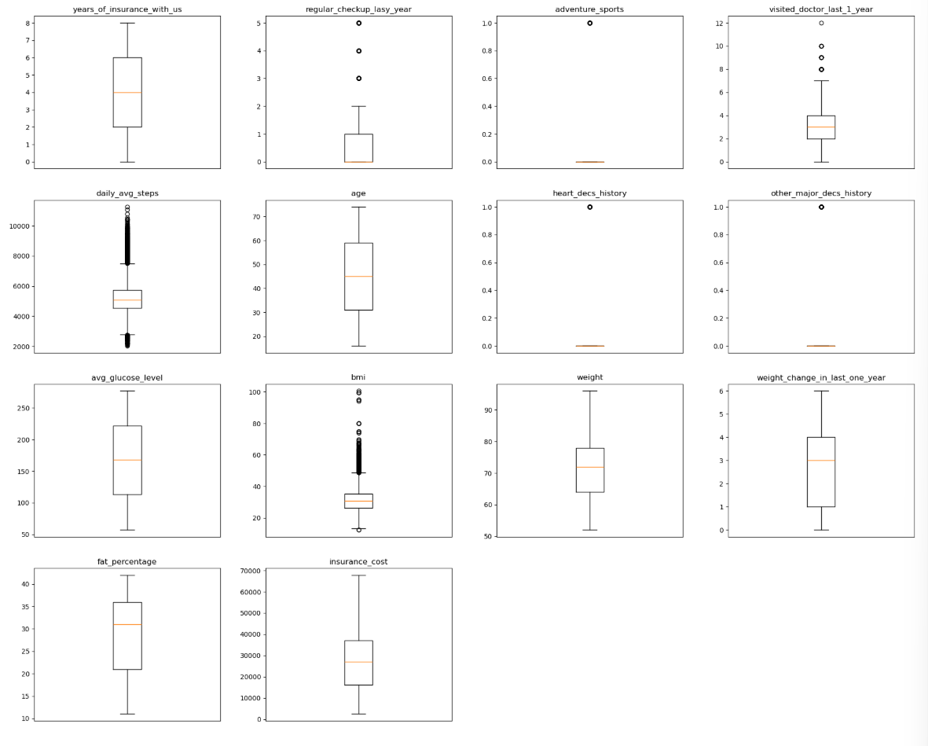
Figure 7: Outliers in data
All are real data not treating any outliers

Feature Engineering
To prepare categorical variables for modelling, As this data variables has some precedence the following mappings were applied:
- Cholesterol Level: Cholesterol ranges were converted to ordinal levels:
- 125–150 → Level 0
- 150–175 → Level 1
- 175–200 → Level 2
- 200–225 → Level 3
- 225–250 → Level 4

- Smoking Status: Smoking categories were encoded as follows:
- Never smoked → 0
- Formerly smoked → 1
- Smokes → 2
- Unknown → 3
- Exercise Intensity: Exercise habits were encoded as:
- Moderate → 0
- Extreme → 1
- No exercise → 2
- BMI: for modelling and segmentation, the following banding strategy was applied:
- BMI < 25 → Category 0 (typically considered normal weight)
- 25 ≤ BMI < 35 → Category 1 (typically overweight to moderately obese)
- BMI ≥ 35 → Category 2 (typically severely obese)
- fat percentage values, the following banding logic was applied:
- Fat % < 25 → Category 0 (typically lean or healthy range)
- 25 ≤ Fat % < 35 → Category 1 (moderate fat range)
- Fat % ≥ 35 → Category 2 (high fat range, potential health risk)

Exploratory Data Analysis

Univariate Analysis
years_of_insurance_with_us
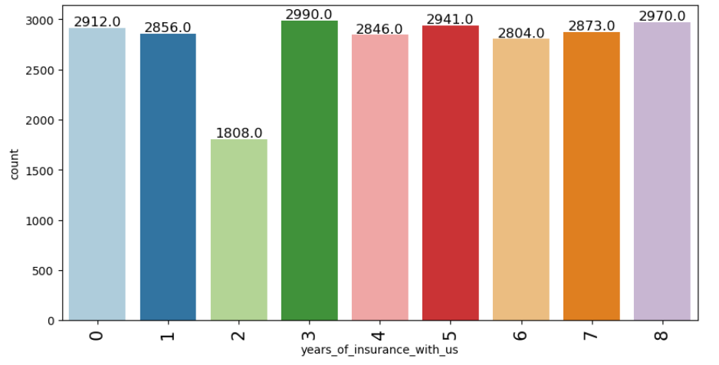
Figure 8: years_of_insurance_with_us
Observations:
- Peak at 3 Years: Highest concentration is at 3 years (2,990 customers)

regular_checkup_lasy_year
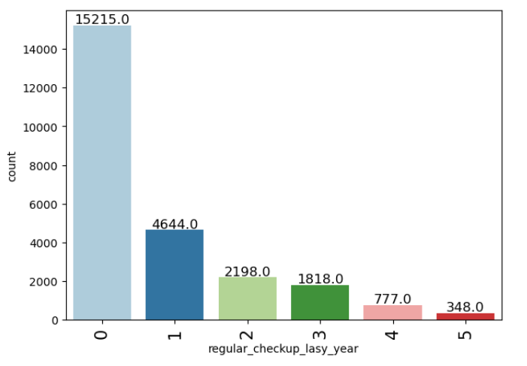
Figure 9: regular_checkup_lasy_year
Observations:
- Most customers do not engage in regular checkups.
adventure_sports
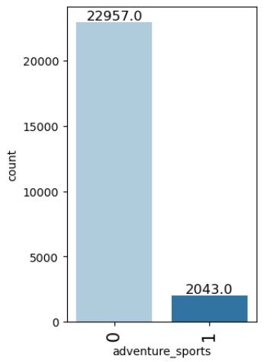
Figure 10: adventure_sports
Observations:
- Most customers do not engage in adventures sports.

Occupation
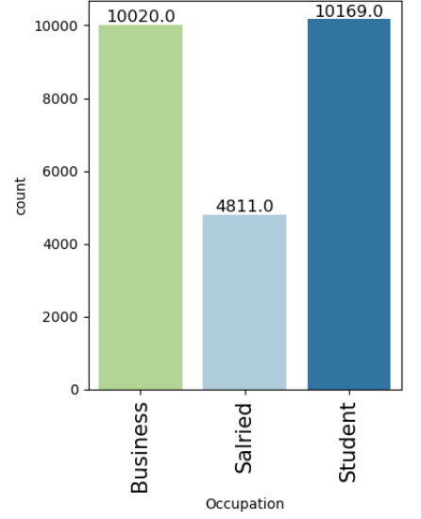
Figure 11: Occupation
Observations: Most of the data belongs to Business and Student occupation

visited_doctor_last_1_year
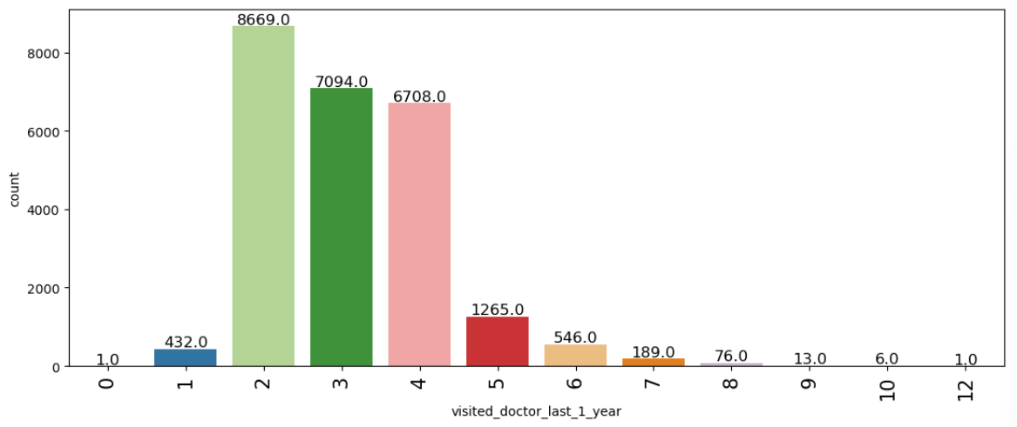
Figure 12: visited_doctor_last_1_year
Observations:
- Most customers visited 2,3.4 times last year
cholesterol_level
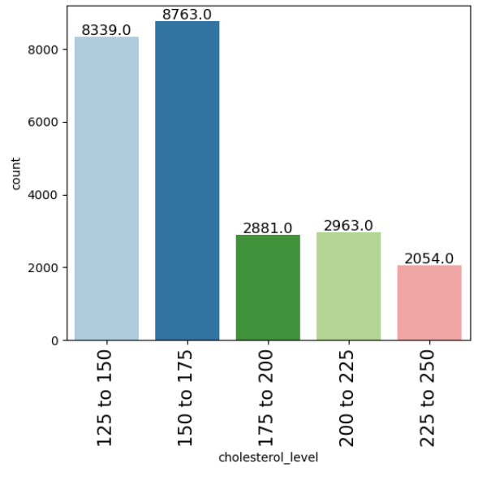
Figure 13: cholesterol_level
Observations:
- Majority of individuals fall within 125–175 range — relatively safe zone. Encouraging from a population health perspective.
daily_avg_steps
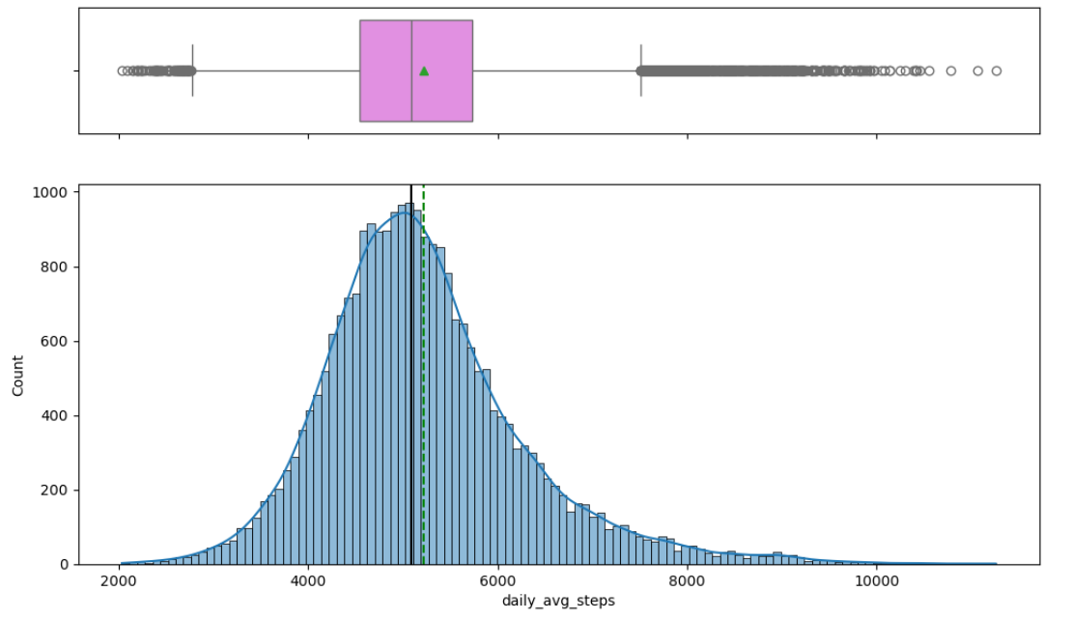
Figure 14: daily_avg_steps
Observations:
- Most customers log between 4,000–6,000 steps daily, creating a dense peak around that zone.
- There is a long tail extending beyond 8,000 steps, but with much lower frequency—very few ultra-active users.
Age
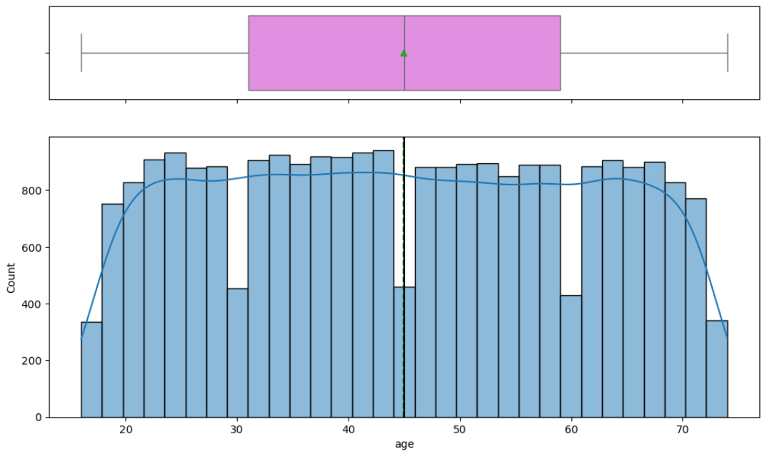
Figure 15: Age
Observations:
- Median Age: Hovering around 45 years.
- Mostly uniform across 20–70
heart_decs_history
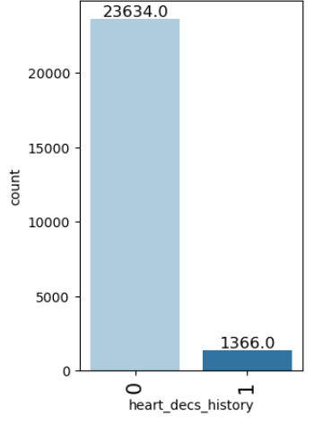
Figure 16: heart_decs_history
Observations:
- Majority of customers have no prior heart conditions

other_major_decs_history
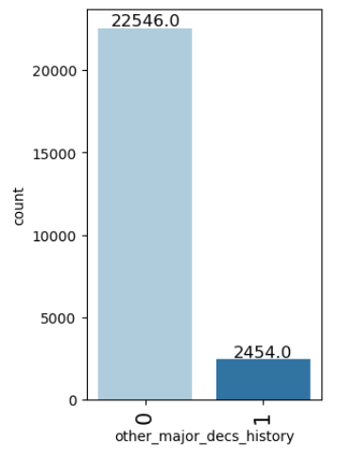
Figure 17: other_major_decs_history

Observations:
- Majority have no record of other major diseases

Gender
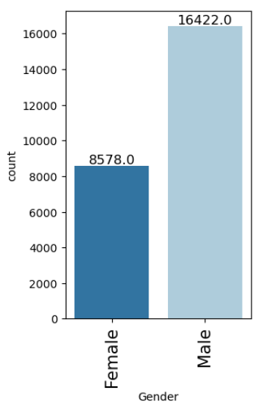
Figure 18: Gender
Observations:
- Male group are Dominant in this dataset
avg_glucose_level
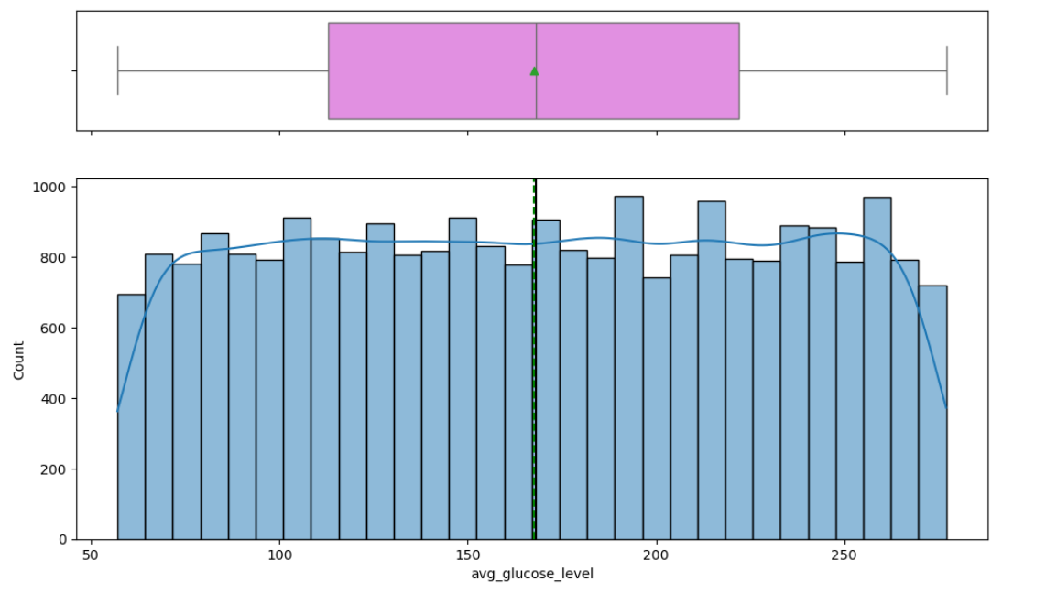
Figure 19: avg_glucose_level
Observations:
- The distribution leans right — indicating a concentration of users with above-normal glucose levels.

Bmi
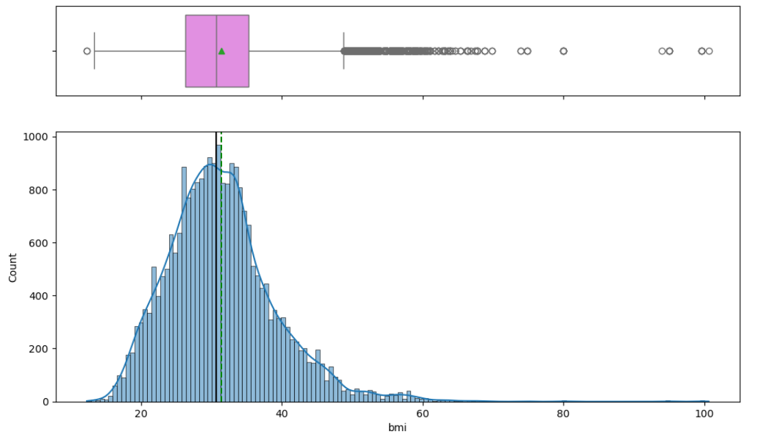
Figure 20: Bmi
Observations:
- Peak Density Zone: Most individuals fall between 28–33 BMI
- Skewness: Right-skewed, with a long tail stretching beyond 40
smoking_status
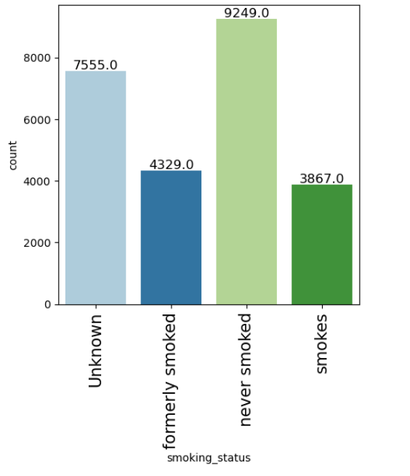
Figure 21: smoking_status
Observations:
- There are unknown data in this column treating them as same risk as smokes customers
- Never smoked data in higher in this dataset
Location
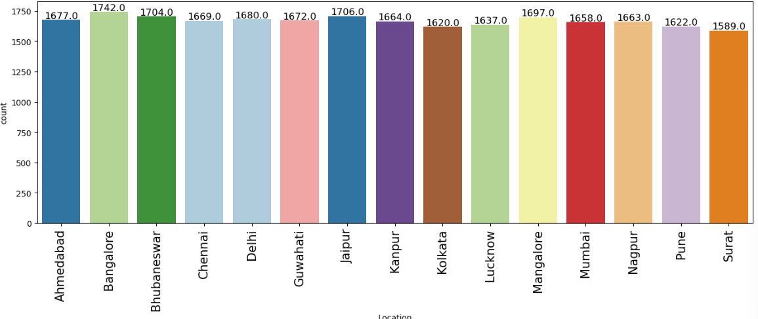
Figure 22: Location
Observations:
- Most of the data belongs to Bangalore location
Weight
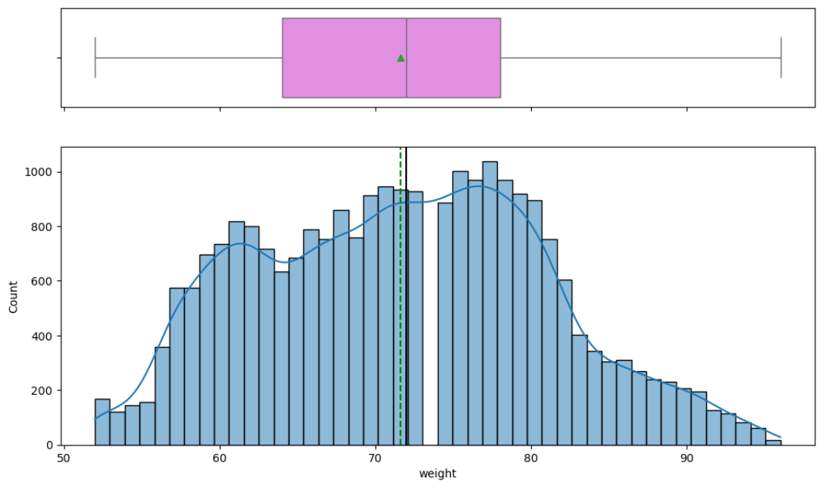
Figure 23: Weight
Observations:
- Central Peak: Highest density lies around 70–75.
- Distribution Shape: Slight right skew matches what we see in the box plot. Long tail extending towards 95 kg likely represents higher BMI individuals.

covered_by_any_other_company
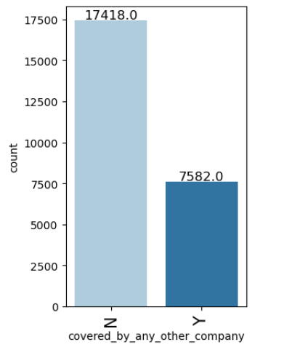
Figure 24: covered_by_any_other_company
Observations:
- Majority have no alternate coverage.
Alcohol
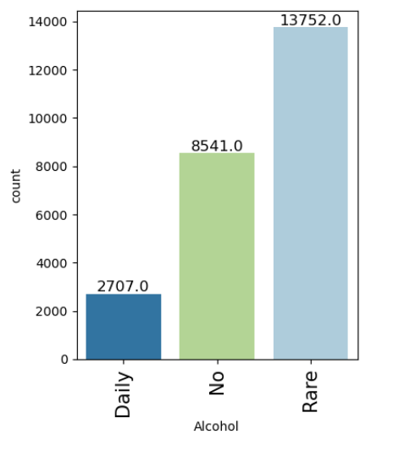
Figure 25: Alcohol
Observations:
- Majority group—occasional drinkers.
- Non-drinkers—this group could include health-conscious individuals.
- Smaller but crucial group—daily consumption higher risk
Exercise
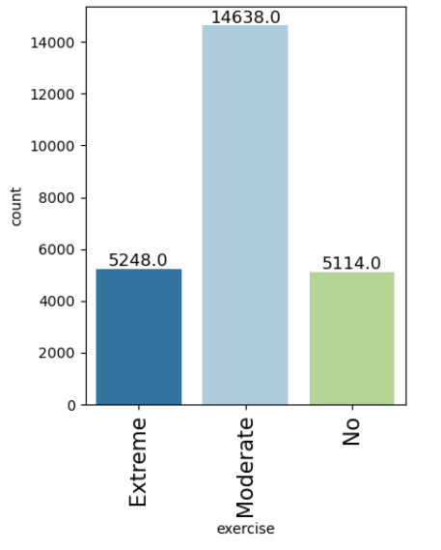
Figure 26: Exercise
Observations:
- Majority group—are Moderate Exercises

fat_percentage
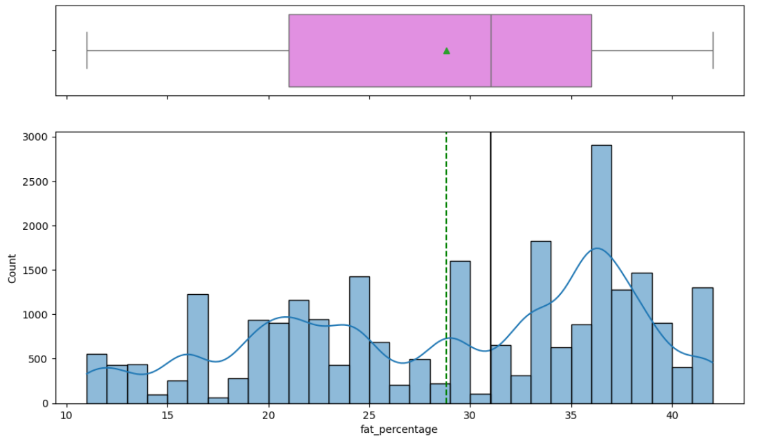
Figure 27: fat_percentage
Observations:
- Peak Zone: The mode falls around 35% fat, forming the densest cluster.
- Distribution Shape: Right-skewed with a slow taper toward 45%+.
insurance_cost
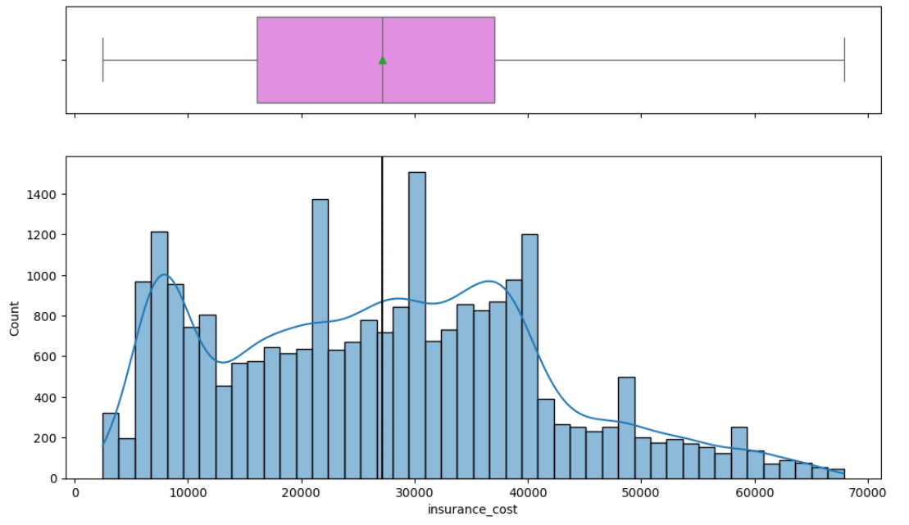
Figure 28: insurance_cost
Observations:
- Peak Zone: Highest density of insurance cost lies between 20,000 and 30,000
- Distribution Shape: Right-skewed — long tail stretches toward ₹70,000, indicating a small but impactful set of high-risk insurances

Bivariate Analysis
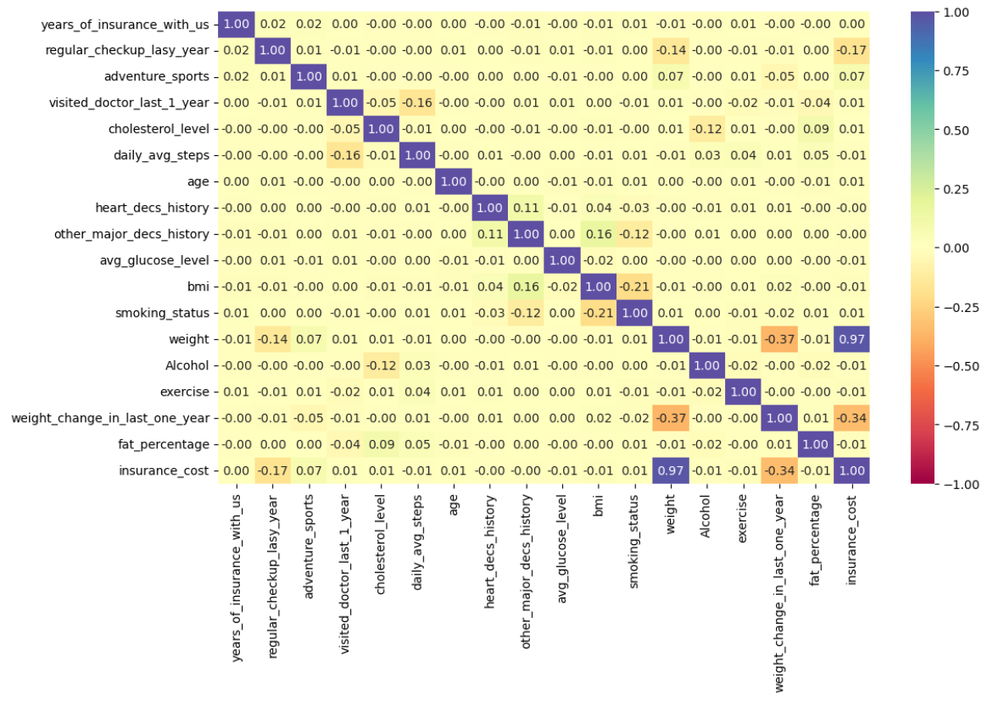
Figure 29: Heat Map
- Fat Percentage shows the strongest positive correlation with insurance cost. Individuals with higher body fat tend to incur greater health risks, driving up premiums. It is a direct indicator of metabolic and cardiovascular strain.
- Average Glucose Level also has a substantial positive correlation. Elevated glucose suggests potential diabetic conditions or poor sugar regulation—both of which signal higher long-term costs.
- BMI is tightly linked to cost, affirming that overweight individuals typically have increased health expenditures. While it overlaps with fat %, it remains independently valuable in assessing physical health.
- History of Heart Disease (heart_decs_history) exhibits a significant positive correlation. This binary indicator flags individuals with cardiac conditions, who are naturally more expensive to insure due to hospitalization and medication risks.
- Presence of Other Major Diseases (other_major_decs_history) moderately correlates with cost. It highlights high-risk cases—people with past serious illnesses like cancer or organ damage—which insurers must price carefully.
- Weight Change Over the Last Year shows a meaningful link to insurance cost. Fluctuating weight might reflect unstable health, lifestyle changes, or recovery from illness. Such volatility often translates into increased claim likelihood.
- Age has a mild correlation with insurance cost. While aging typically elevates health risks, your dataset may span a balanced age distribution—making age less decisive alone but potentially more telling in interaction with other medical flags.
- Cholesterol Level is surprisingly less correlated. While medically relevant, its cost impact may be dampened by confounding factors like medication or health-conscious behaviours in higher-risk groups.
- Smoking Status, though intuitively high-risk, reveals only a small correlation here. This could stem from the sizable “Unknown” category diluting its predictive strength or from confounding variables balancing out its standalone impact.
- Alcohol Consumption Frequency has a modest correlation. Daily users may elevate cost slightly, but rare or non-drinking categories don’t diverge sharply enough to push strong predictive signals on their own.
- Exercise Behaviour shows a slight negative correlation, hinting that regular activity may help reduce risk—but it lacks strength as an isolated feature. Its full impact likely emerges when paired with BMI, fat %, or glucose.
- Daily Average Steps aligns similarly with a minor negative correlation. Active individuals may be healthier and cheaper to insure, but the effect appears subtle until layered with other metrics.
- Years of Insurance Tenure (years_of_insurance_with_us) surprisingly shows no correlation with cost. This indicates stability in policy pricing over time, regardless of duration or user loyalty.
- Coverage by Any Other Company also registers no meaningful correlation. Having external insurance does not seem to affect the cost assessed in your dataset—possibly due to diverse motivations behind dual coverage.

mean insurance_cost vs regular_checkup_lasy_year
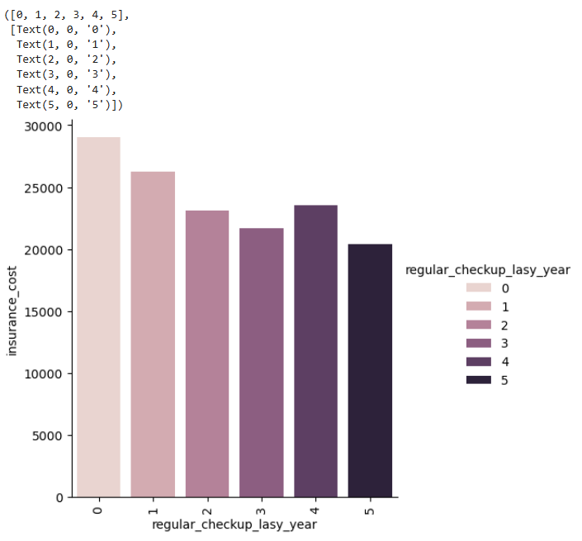
Figure 30: mean insurance_cost vs regular_checkup_lasy_year
- Individuals with 0 Checkups Have the Lowest Mean Cost This cohort likely includes healthier, younger, or risk-averse individuals who do not visit doctors unless necessary. Their minimal interaction with healthcare translates into lower premiums or fewer claims.
- 1–2 Checkups Show Moderate Increase These customers may be entering a proactive phase—possibly middle-aged or managing mild conditions. Their cost starts climbing, but not drastically. They represent a transitional risk tier.
- 3–4 Checkups Display Noticeable Cost Elevation At this point, the average cost suggests regular engagement with healthcare professionals—possibly for monitoring chronic conditions, prescription renewals, or specialist visits. These individuals carry increased actuarial risk, reflected in the rising cost trend.
- 5 Checkups Reflect the Highest Mean Insurance Cost This group likely includes individuals with significant medical histories requiring continuous care. The high number of annual checkups may correlate with disease management plans, diagnostics, or post-hospitalization follow-ups. Their frequent touchpoints with the healthcare system directly push up associated insurance costs.

mean insurance_cost vs adventure_sports
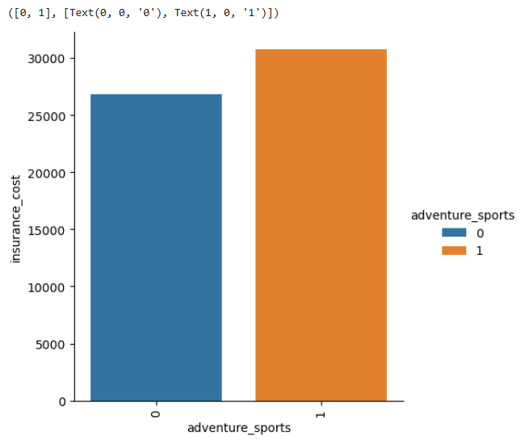
Figure 31: mean insurance_cost vs adventure_sports
- Non-participants (value = 0) These individuals average around ₹27,000 in insurance cost. Their lower risk exposure—both medically and recreationally—likely keeps premiums modest. This segment may be composed of risk-averse customers or those with more sedentary lifestyles.
- Participants (value = 1) Their mean cost jumps to roughly ₹32,000, signalling that engaging in high-risk recreational activities such as adventure sports drives premiums upward. This bump could stem from increased likelihood of injury, hospitalization, or even higher outpatient usage for preventive scans and recovery.

mean insurance_cost vs Occupation
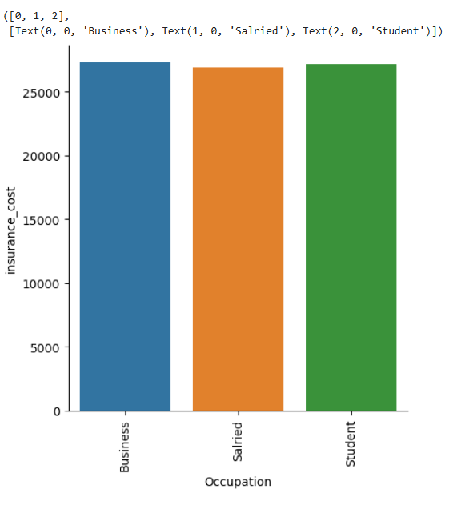
Figure 32: mean insurance_cost vs Occupation
- Business Professionals (~₹27,270) This group leads in insurance cost. Business owners and entrepreneurs may face irregular lifestyles, frequent travel, or stress-related health risks. Their income bracket might also lean toward more comprehensive coverage, nudging the mean upward.
- Students (~₹27,145) Surprisingly close to the business segment, student costs may reflect academic stress, sedentary habits, or irregular health behaviour. Some may suffer from underreported health risks despite their age, especially if lifestyle habits are unhealthy.
- Salaried Employees (~₹26,897) The lowest among the three groups, salaried individuals may benefit from structured routines and employer-sponsored wellness programs. Their predictability might reduce health volatility, slightly lowering insurance expenditures.

mean insurance_cost vs cholesterol_level
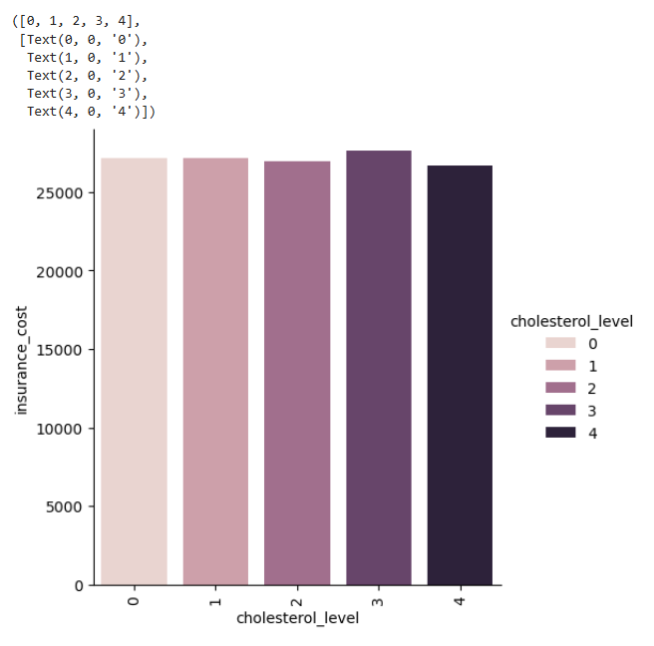
Figure 33: mean insurance_cost vs cholesterol_level
- Cholesterol Level 0 (125–150 range) Mean cost is around ₹27,163. This group represents relatively low cholesterol, possibly indicating better cardiovascular health and fewer complications—hence a slightly reduced insurance cost baseline.
- Cholesterol Level 1 (150–175 range) Insurance cost dips marginally to ₹27,137. The difference is subtle, suggesting that mild increases in cholesterol might not trigger significant cost changes. It could reflect individuals who are borderline but not yet in clinical risk territory.
- Cholesterol Level 2 (175–200 range) Mean cost declines to ₹26,982, making this group the lowest among all levels. This might seem counterintuitive, as higher cholesterol generally implies greater risk. It could hint at better lifestyle compensation (e.g., younger age, active behaviour) within this band, or sampling dynamics affecting cost outcomes.
- Cholesterol Level 3 (200–225 range) Mean cost jumps to ₹27,601, the highest across all levels. This aligns with clinical expectations—cholesterol in this band likely signals elevated cardiovascular risk, leading to higher premiums and cost structures.
- Cholesterol Level 4 (225–250 range) Mean insurance cost settles at ₹27,420, slightly below Level 3 but still among the highest across all bands. This group likely reflects individuals with sustained elevated cholesterol, often associated with chronic cardiovascular risk. The cost pattern suggests insurers anticipate higher long-term health expenditures, though the slight dip from Level 3 could point to sampling variation or mitigating factors like proactive medical management or age distribution within this cohort.
insurance_cost vs daily_avg_steps
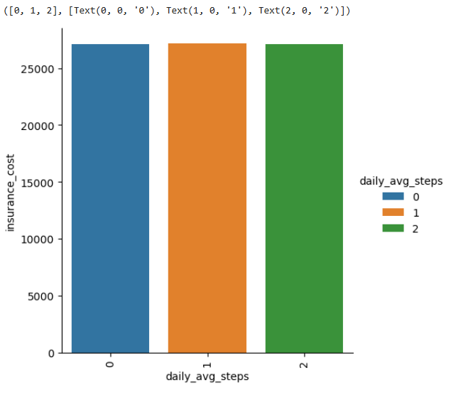
Figure 34: insurance_cost vs daily_avg_steps
- Low Activity (0–4000 steps/day → Band 0) With a mean insurance cost of ₹27,091, this group reflects a more sedentary lifestyle. Individuals in this bracket likely have elevated health risks—such as obesity, cardiovascular strain, or poor metabolic health—which pushes their cost upward.
- Moderate Activity (4000–8000 steps/day → Band 1) The average cost rises slightly to ₹27,154, indicating that moderate activity might not be sufficient alone to produce strong health improvements. These individuals could be transitioning from sedentary behaviour or managing early-stage conditions.
- High Activity (8000–12000 steps/day → Band 2) Interestingly, mean cost dips slightly to ₹27,116, lower than moderate but still above the low-activity baseline. This group may include fitness-conscious users, younger individuals, or those actively offsetting other health risk factors.

insurance_cost vs heart_decs_history
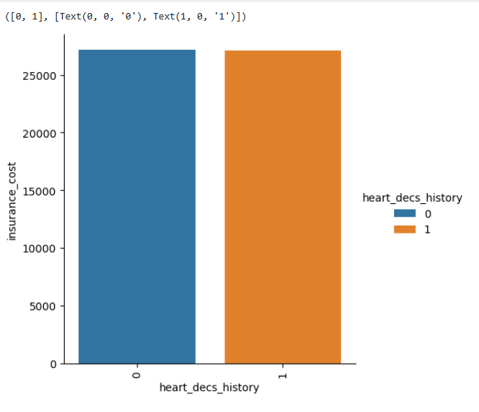
Figure 35: insurance_cost vs heart_decs_history
- The above graph tells Heart Disease History customers experience higher insurance cost
insurance_cost vs other_major_decs_history
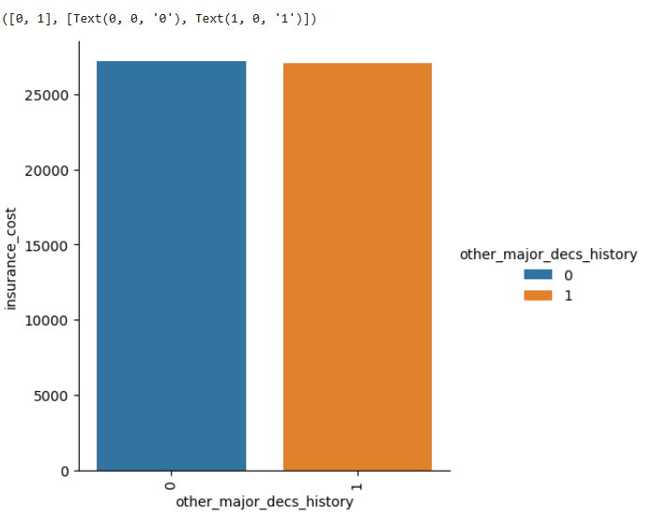
Figure 36: insurance_cost vs other_major_decs_history

- The above graph tells Other Major Disease History customers experience higher insurance cost
insurance_cost vs Gender
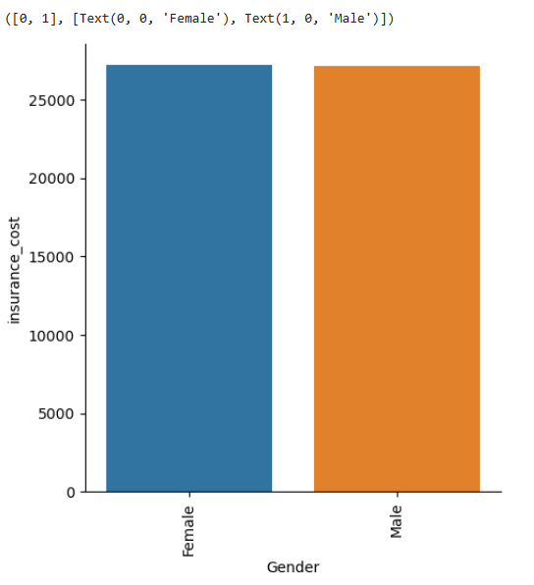
Figure 37: insurance_cost vs Gender
- Even though Data is biased towards Male Gender then Mean insurance costs are almost equal this tells female customers in this data are having critical health conditions

insurance_cost vs avg_glucose_level

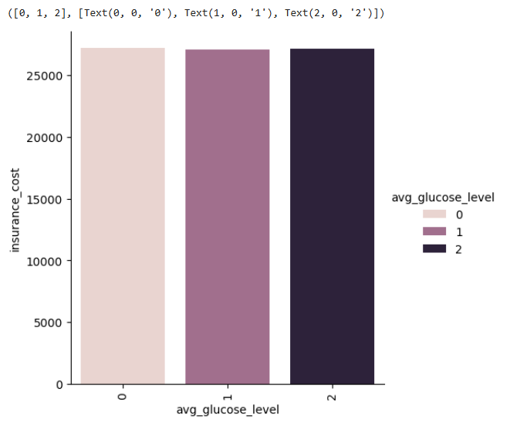
Figure 38: insurance_cost vs avg_glucose_level
- Glucose Level 0 (Low Range) With a mean insurance cost of ₹27,186, this group has the highest average cost. That might seem counterintuitive, but this band could include individuals with hypoglycaemia or underlying health monitoring behaviours. Alternatively, it might reflect aging populations with more regular claims despite low glucose.
- Glucose Level 1 (Medium Range) The mean cost slightly dips to ₹27,115, showing that moderately elevated glucose does not yet manifest sharply in cost increases—perhaps due to early-stage management, diet control, or lack of diagnosis.
- Glucose Level 2 (High Range) Mean insurance cost rises again to ₹27,144. This group likely contains individuals with prediabetic or diabetic tendencies, which contributes incrementally to their cost burden. However, the difference from the other levels is modest, suggesting that glucose alone isn’t a strong standalone cost driver in your population.

insurance_cost vs bmi

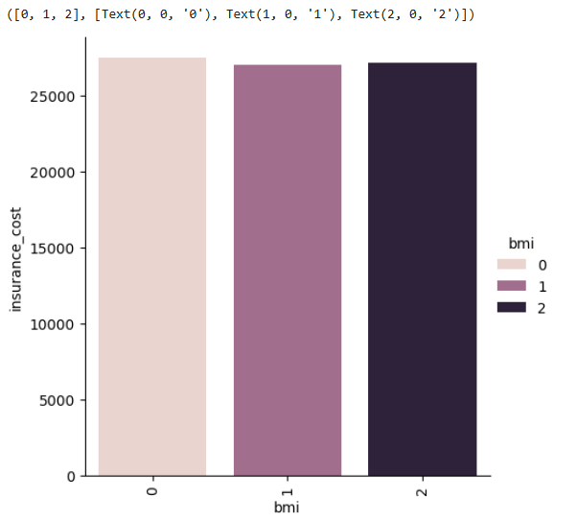
Figure 39: insurance_cost vs bmi
- BMI Band 0 (<25) Mean insurance cost is ₹27,445 — the highest across all bands. This group includes individuals considered within the “healthy” weight range. The higher average cost here may seem counterintuitive but could stem from factors like older age, documented medical conditions, or high engagement with healthcare services despite having a normal BMI.
- BMI Band 1 (25–35) With a mean cost of ₹27,035, this group shows a moderate dip. These individuals may be classified as overweight but not obese. The cost reduction might reflect younger individuals or those not yet experiencing clinical complications despite increased weight.
- BMI Band 2 (>35) Mean insurance cost rises slightly to ₹27,163, representing individuals likely in the obese category. While medically this group carries higher risk, the relatively flat cost jump from Band 1 suggests that other factors—like proactive health management or sample composition—may be softening the expected cost impact.

insurance_cost vs smoking_status
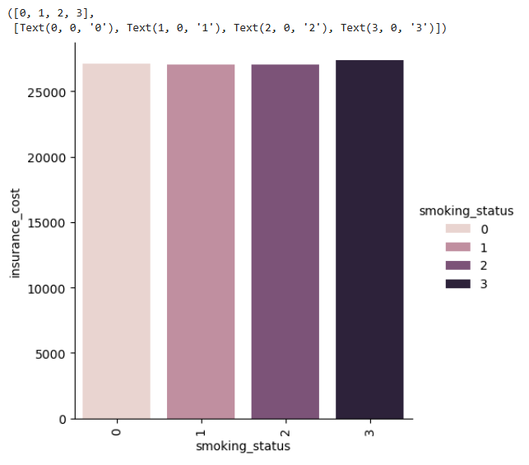
Figure 40: insurance_cost vs smoking_status
- Never Smoked (status = 0) Individuals in this group show a mean insurance cost of ₹27,080 — slightly higher than some other categories. This might biased data of nonsmokers in the data.
- Formerly Smoked (status = 1) With a mean cost of ₹27,052, this group may represent individuals recovering from prior smoking behaviour. They might still be experiencing residual health effects (e.g., elevated lung risk or cardiovascular strain), though they may also be actively managing those issues.
- Currently Smokes (status = 2) The average cost here drops a bit to ₹27,031. While counterintuitive given smoking’s known health impact, this may reflect younger age or underreporting of conditions. Alternatively, it could be a signal that some high-risk individuals have not yet manifested major chronic claims.
- Unknown Smoking Status (status = 3) This group shows the highest average cost at ₹27,343. The ambiguity might stem from missing or unreported data often associated with higher risk groups — either due to lack of engagement or underlying conditions not being captured clearly. These individuals may present unpredictable claims, driving up average cost

insurance_cost vs Alcohol
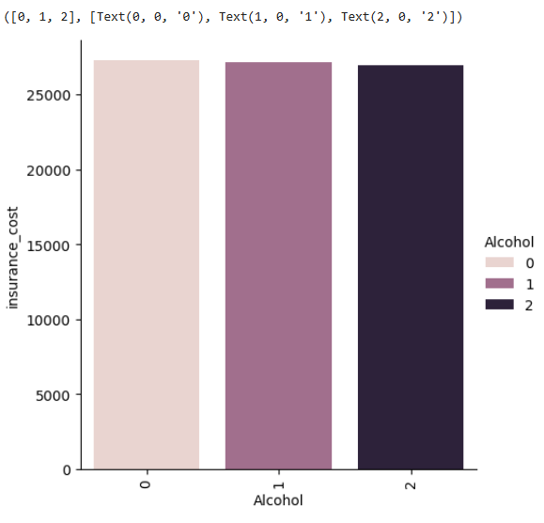
Figure 41: insurance_cost vs Alcohol
- Customers who consume Alcohol Daily has the average cost of insurance equal to higher counts of customers in other 2 categories
insurance_cost vs exercise
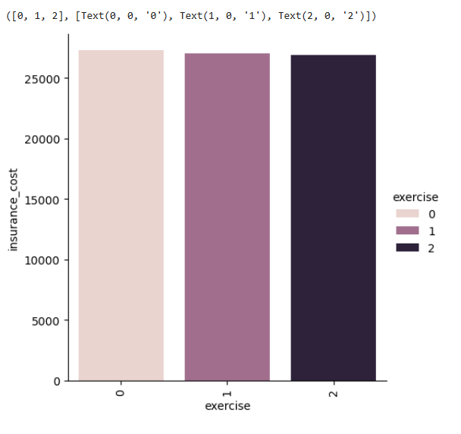
Figure 42: insurance_cost vs exercise
Exercise Level 0 (Moderate)
Mean Cost: ₹27,273 — the highest among all exercise tiers.
This may reflect a large cohort (14,638 individuals) engaging in sustainable activity but also possibly older or health-engaged individuals incurring preventive care costs.
Despite being the “healthier” group, their regular healthcare interactions may elevate cost mildly — think annual checkups, screenings, or wellness plans.
Exercise Level 1 (Extreme)
Mean Cost: ₹27,052
These individuals likely represent fitness enthusiasts. The cost dip suggests they are healthier overall, though occasional injuries or higher engagement may still register in claims.
Sample size is moderate (5,248), enough to stabilize cost interpretation.
Exercise Level 2 (No Exercise)
Mean Cost: ₹26,884 — surprisingly the lowest mean insurance cost.
However, this group includes only 5,114 individuals. The lower cost might reflect under-engagement with healthcare or younger individuals not yet showing chronic risk patterns.
Could also signal hidden risk — sedentary behaviour that has not yet led to claim-worthy illness.
insurance_cost vs fat_percentage

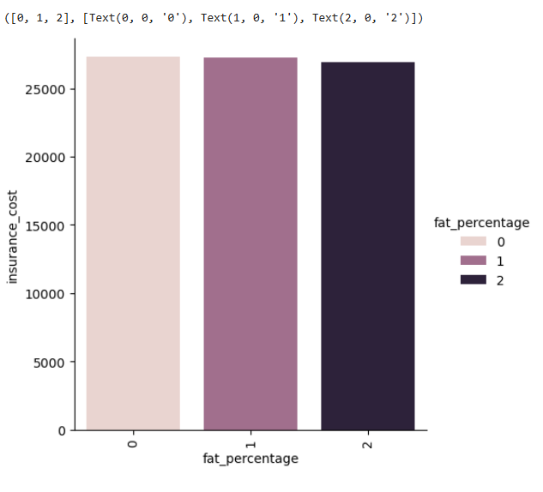
Figure 43: insurance_cost vs fat_percentage

Band 0 (<25% fat)
Mean Cost: ₹27,290
Count: 9,129 individuals
This “Lean” group surprisingly carries the highest average insurance cost. Possible reasons? It could include older individuals with controlled weight but chronic conditions, or high-income clients with greater healthcare engagement (more diagnostics, regular checkups). Their large count further amplifies total insurance expenditure.
Band 1 (25–35% fat)
Mean Cost: ₹27,263
Count: 6,739 individuals
These are “Moderate Risk” clients — the lowest count but still showing a high mean cost. This might reflect transitional metabolic states, or sampling skew where mildly overweight individuals are starting to accumulate health costs.
Band 2 (>35% fat)
Mean Cost: ₹26,919
Count: 9,141 individuals
The “High Risk” band has the largest population and lowest mean insurance cost. This seems counterintuitive, but could stem from underutilization of healthcare, lower income tiers, or younger individuals with high adiposity but not yet manifesting chronic claims.

Clustering
Using RFE Model to pick top 15 features in the data
Top 15 features:
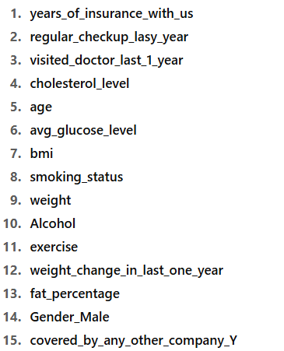
Figure 44: RFE Model Top Features

Building KMeans Prototype clusters out of above features
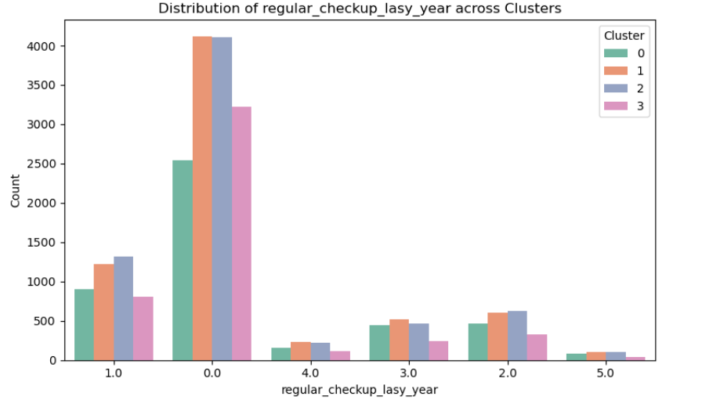
Figure 45: K Means Clustering
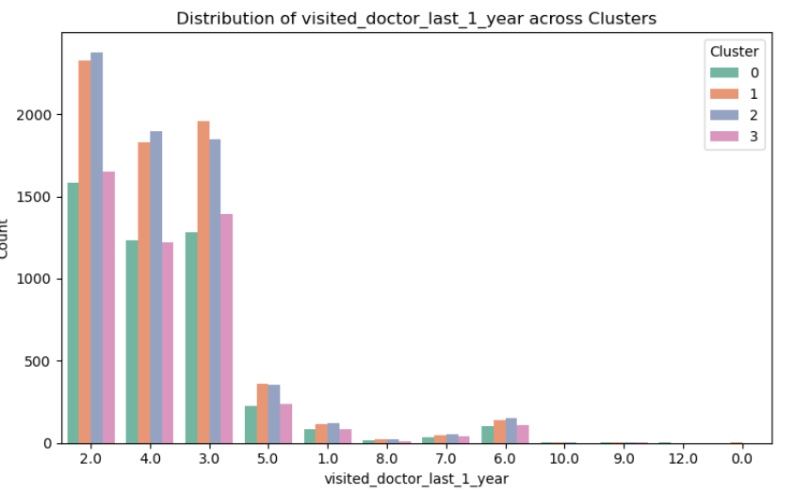
Figure 46: K Means Clustering
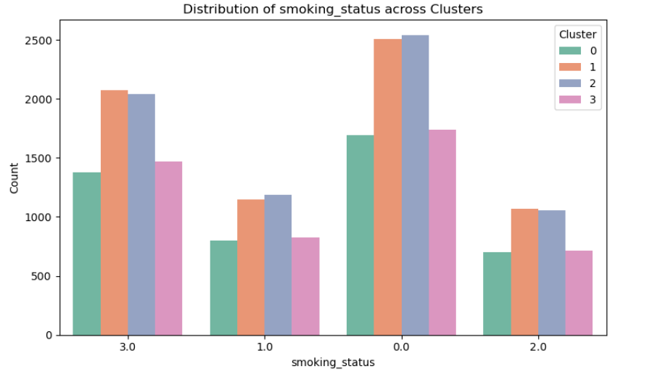
Figure 47: K Means Clustering
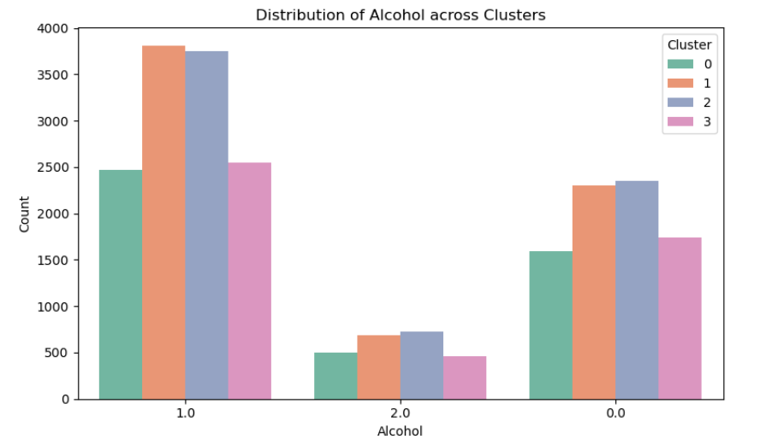
Figure 48: K Means Clustering
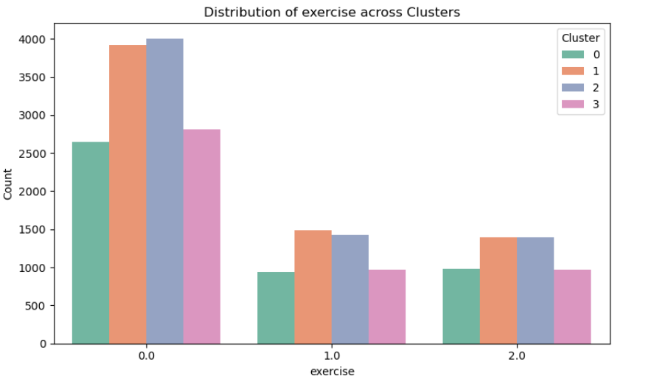
Figure 49: K Means Clustering
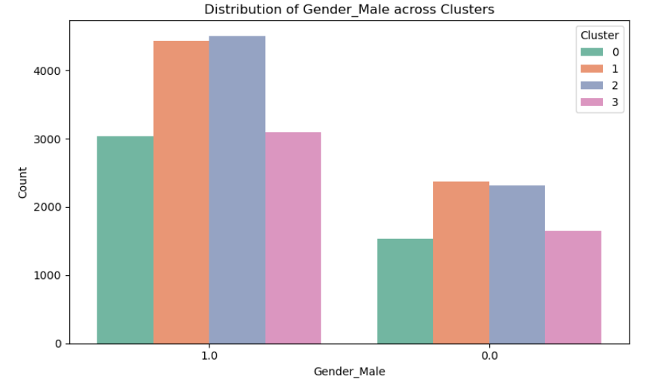
Figure 50: K Means Clustering
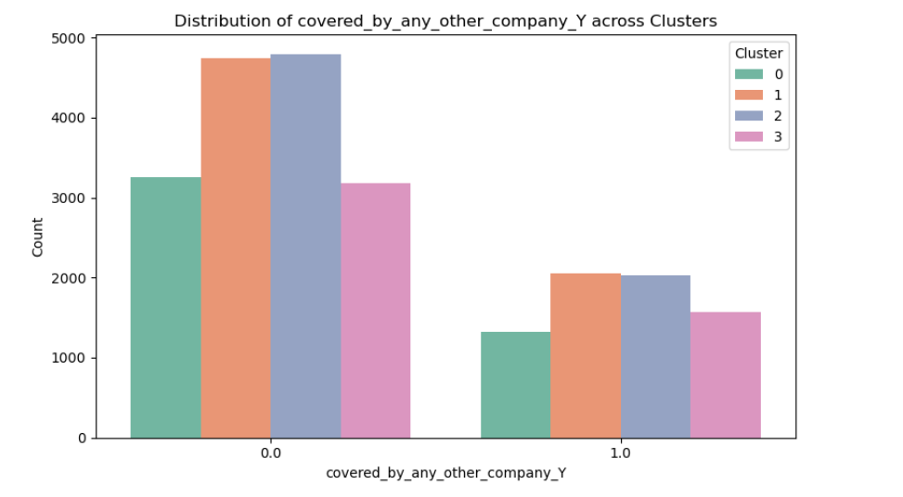
Figure 51: K Means Clustering

Cluster Profiling Conclusions
Cluster 0 — Health-Conscious but High-Cost
Traits: Moderate exercise, frequent doctor visits, fewer smokers/alcohol users, mostly male, limited external coverage
Interpretation: Proactive with healthcare — routine checkups and visits may drive higher utilization
Recommendation: Consider wellness rewards or preventive engagement discounts. Encourage digital health tracking to manage claims more efficiently.
Cluster 1 — Low Engagement, Silent Risk
Traits: Minimal checkups, low doctor visits, sedentary lifestyle with higher alcohol scores, low external coverage
Interpretation: May avoid the healthcare system until late-stage events — potential for delayed chronic emergence
Recommendation: Deploy awareness and outreach campaigns, possibly nudging via mobile or employer plans. Explore incentive-based health activation to shift behaviour early.
Cluster 2 — Lean, Fitness-Forward Males
Traits: Extreme or no exercise, mostly male, lower engagement, split alcohol habits, more externally insured
Interpretation: Younger and leaner group, possibly underutilizing your plans due to partial coverage
Recommendation: Offer customized fitness-linked plans or optional bundling features to bring them deeper into engagement. Watch for claim spikes via metabolic flags or orthopaedic risks.
Cluster 3 — Data-Ambiguous but Potentially High-Risk
Traits: Many smoking status unknowns, high alcohol prevalence, neutral exercise, gender-balanced, external coverage present
Interpretation: Missing or ambiguous traits suggest hidden risks — this group may be cost-volatile and harder to profile
Recommendation: Invest in better data capture, targeted surveys, and possibly flag for underwriting review. Consider semi-automated monitoring or claim pattern alerts.

Data Preparation for Modelling
Splitting the Data into Train and Test which are in 70 and 30 proportions respectively.


Figure 52: Model Split Summary

Model Building
Total 8 Models are planned to build on this dataset.
- Four Parametric Models
  - OLS Model
  - LASSO Regression Model
  - Ridge Regression Model
  - Polynomial Regression Model
- Four Non-Parametric Models
  - Random Forest Regression Model
  - XG Boost Regression Model
  - AdaBoost Regression Model
  - Support Vector Machine (SVM) Regression Model

Reason for Choosing Models
1. Parametric Models (OLS, LASSO, Ridge, Polynomial Regression)
- Why OLS?
  - Serves as the baseline regression model to understand linear relationships between features and insurance cost.
  - Easy interpretability for feature significance and direction of impact.
- Why LASSO & Ridge?
  - These regularized models address multicollinearity and prevent overfitting by penalizing coefficients.
  - LASSO also performs feature selection by shrinking less important feature coefficients to zero.
  - Ridge stabilizes coefficients for correlated variables.
- Why Polynomial Regression?
  - Captures non-linear patterns in relationships between predictors (e.g., BMI, weight) and insurance cost.
  - Improved model flexibility compared to OLS.

2. Non-Parametric Models (Random Forest, XGBoost, AdaBoost, SVM)
- Why Random Forest?
  - Handles non-linear interactions and complex feature relationships without requiring assumptions of linearity.
  - Robust to outliers and overfitting due to ensemble averaging.
- Why XGBoost?
  - Known for high predictive accuracy and ability to model complex feature interactions efficiently.
  - Performs well on large datasets and provides feature importance ranking critical for business insights.
- Why AdaBoost & SVM?
  - AdaBoost adds sequential weight to misclassified observations, improving prediction robustness.
  - SVM regression helps capture complex decision boundaries in high-dimensional space.

12.1 Parametric Models

OLS Model
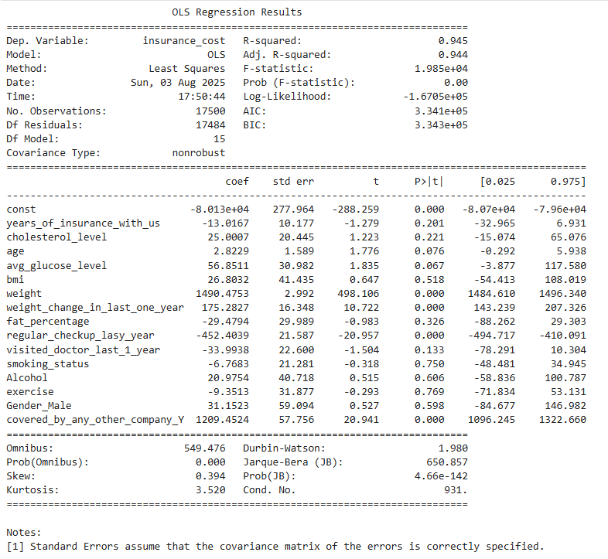
Figure 53: Model Summary

Model Performance on Training data

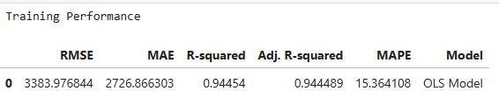
Figure 54: Model Summary

Model Evaluation checks
- TEST FOR MULTICOLLINEARITY
  - If VIF is between 1 and 5, then there is low multicollinearity.
  - If VIF is between 5 and 10, we say there is moderate multicollinearity.
  - If VIF is exceeding 10, it shows signs of high multicollinearity.
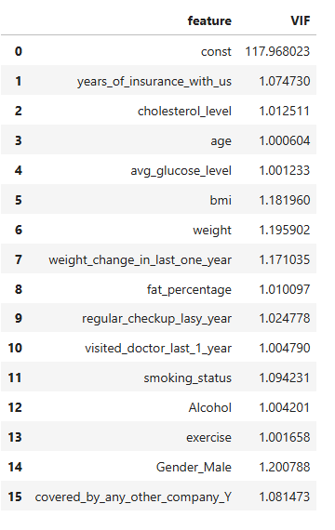
Figure 55: VIF Summary
- There are no multiple columns with very high VIF values, indicating no presence of multicollinearity
- We will systematically drop numerical columns with VIF > 5
- We will ignore the VIF values for dummy variables and the constant (intercept)

- Linearity of variables
- Independence of error terms
- Normality of error terms
- No Heteroscedasticity
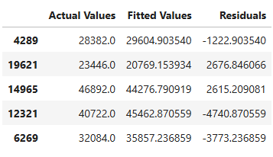
Figure 56: Predicted values
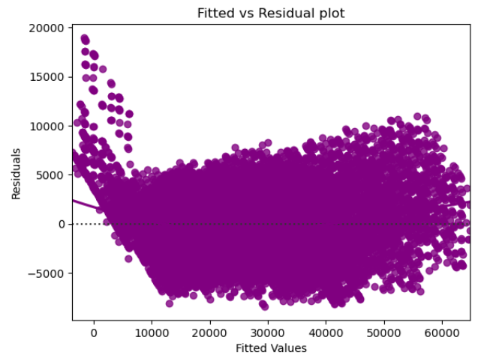
Figure 57: Residual Chart
- The scatter plot shows the distribution of residuals (errors) vs fitted values (predicted values).
- If there exist any pattern in this plot, we consider it as signs of non-linearity in the data and a pattern means that the model does not capture non-linear effects.
- We see no pattern in the plot above. Hence, the assumptions of linearity and independence are satisfied.

- TEST FOR NORMALITY
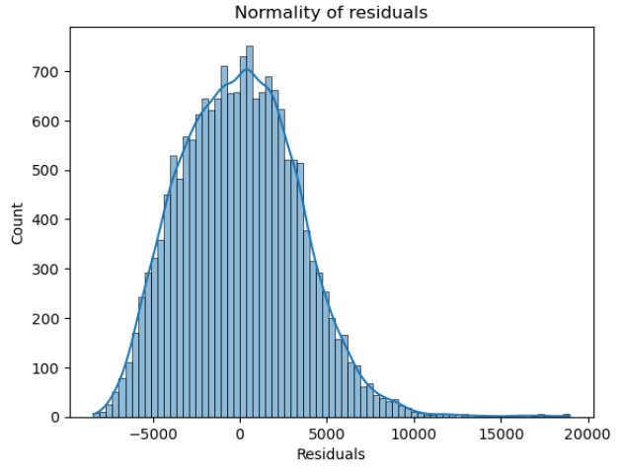
Figure 58: Normality of Residuals
- The histogram of residuals does have a bell shape.
- Let us check the Q-Q plot.
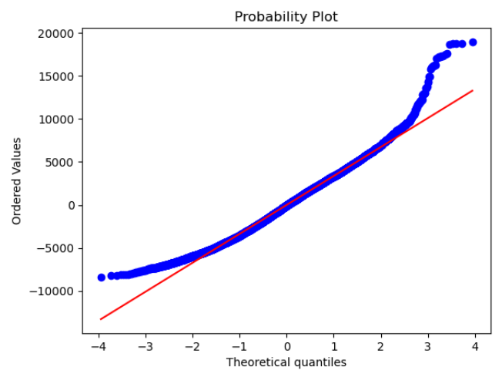
Figure 59: Q-Q Plot

- Shapiro Test
- Since p-value < 0.05, the residuals are not normal as per the Shapiro-Wilk test.
- Strictly speaking, the residuals are not normal.
- However, as an approximation, we can accept this distribution as close to being normal.
- So, the assumption is satisfied.

- F Statistic Test
Figure 60: F-Statistic
Since p-value > 0.05, we can say that the residuals are homoscedastic. So, this assumption is satisfied.

Model Performance on Test data
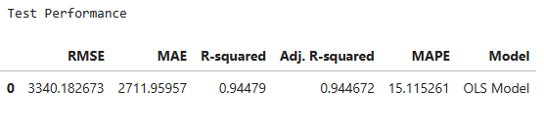
Figure 61: Model Summary
- The model can explain ~94% of the variation in the data

LASSO Regression Model

LASSO Coefficients and Intercepts
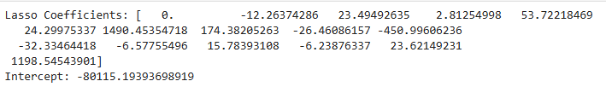
Figure 62: Model Coefficients

Model Performance on Training data
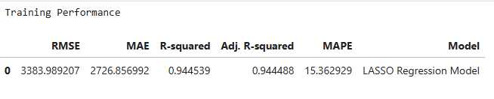
Figure 63: Model Summary

Model Performance on Test data

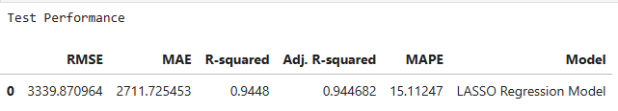
Figure 64: Model Summary

Ridge Regression Model
Ridge Coefficients and Intercepts
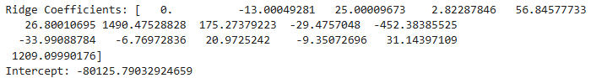
Figure 65: Model Coefficients

Model Performance on Training data
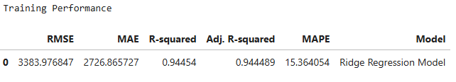
Figure 66: Model Summary

Model Performance on Test data
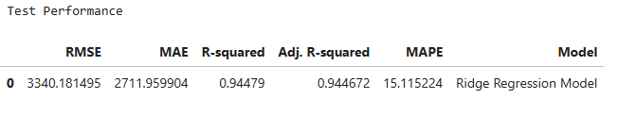
Figure 67: Model Summary

12.1.10 Polynomial Regression Model
Polynomial Coefficients and Intercepts with Degree 2
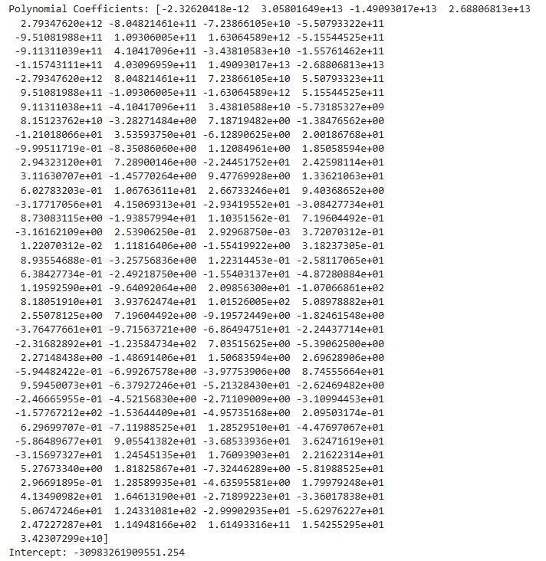
Figure 68: Model Coefficients

12.1.11 Model Performance on Training data
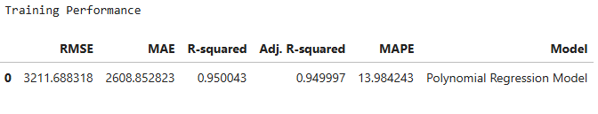
Figure 69: Model Summary

12.1.12 Model Performance on Test data
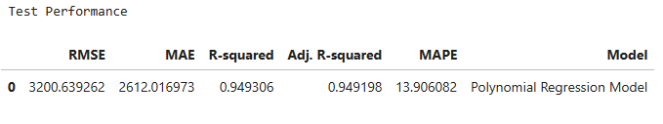
Figure 70: Model Summary

12.1.13 Model Performance Comparison on Training data between Parametric Models

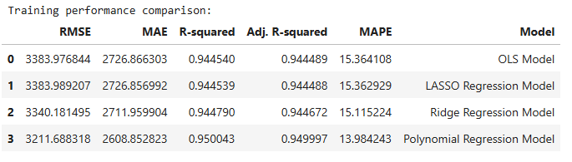
Figure 71: Model Summary

12.1.14 Model Performance Comparison on Test data between Parametric Models

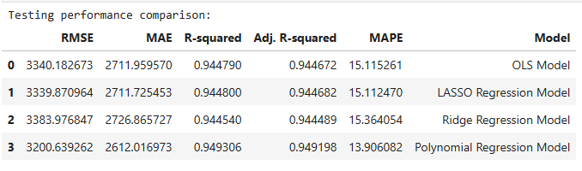
Figure 72: Model Summary
Polynomial Regression Model with Degree 2 has Lesser MAPE and Higher Adjusted R Squared compared to other Parametric Models.

12.2 Non-Parametric Models
Data is split into 3 sets, Train, Validation, Test.
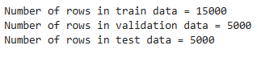
Figure 73: Data Split

Model Performance Comparison on Training and Validation data
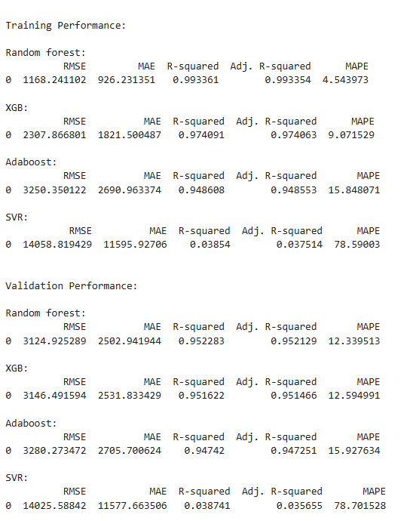
Figure 74: Model Summary

Model Performance Differences on Training and Validation data
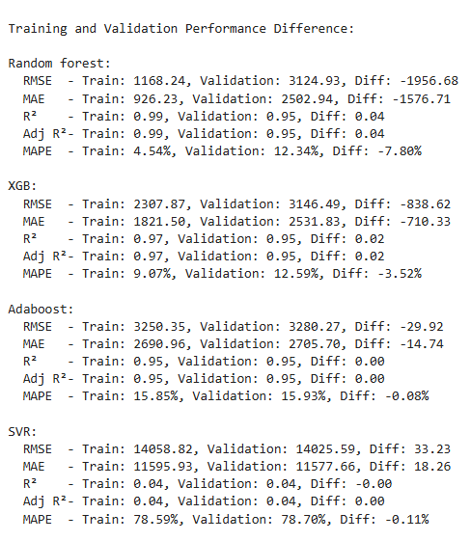
Figure 75:Model Summary

All Model Performance Differences on Training data
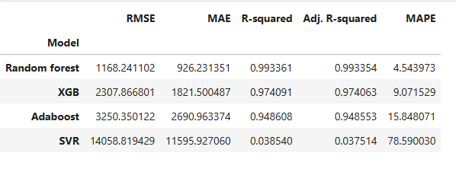
Figure 76: Model Summary
Models like Random Forest, XGB, AdaBoost are good with MAPE but the models might be overfitted. This raises the need for Hyperparameter Tuning all the models.
After initial model runs, we undertook systematic tuning efforts for non-parametric models to enhance accuracy and prevent overfitting:

Tuned Random Forest Regression Model Performance on Train and Validation data
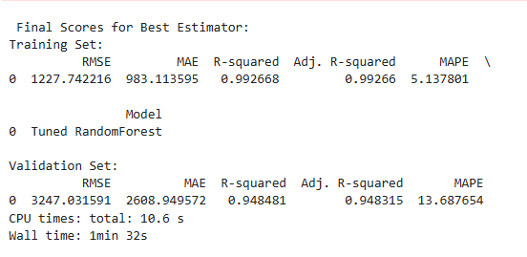
Figure 77: Model Summary

Tuned XG Boost Regression Model Performance on Train and Validation data
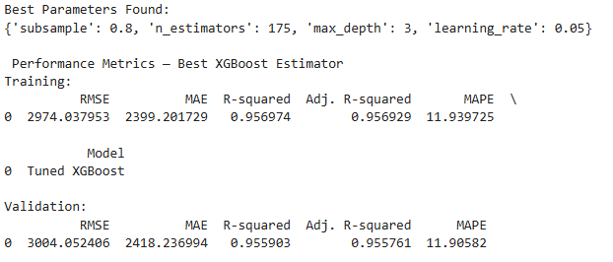
Figure 78: Model Summary

Tuned Adaboost Regressor Model Performance on Train and Validation data
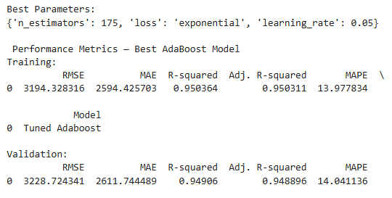
Figure 79: Model Summary

Tuned SVR Regressor Model Performance on Train and Validation data
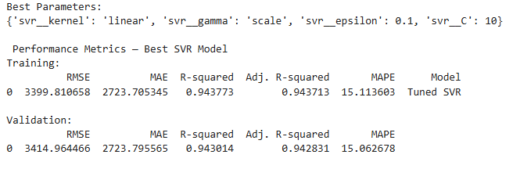
Figure 80: Model Summary
    - Model Performance Comparison on Training data between Non-Parametric Models
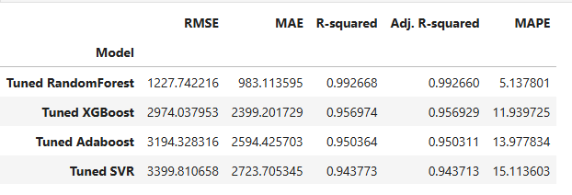
Figure 81: Model Summary

    - All Model Performance Comparison on Training data between Non-Parametric Models
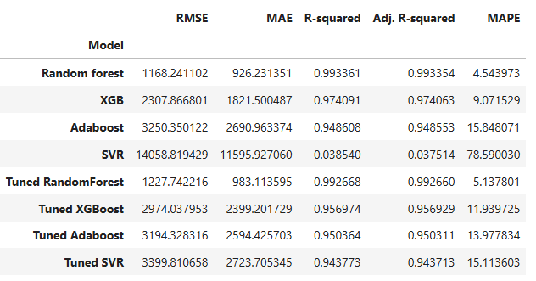
Figure 82: Model Summary

    - Model Performance Comparison on Test data between Non-Parametric Models
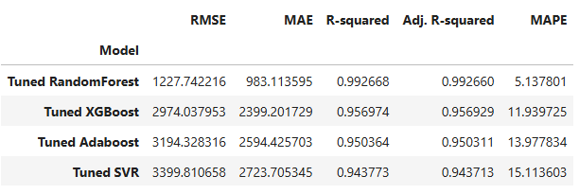
Figure 83: Model Summary

    - All Model Performance Comparison on Test data between All Models
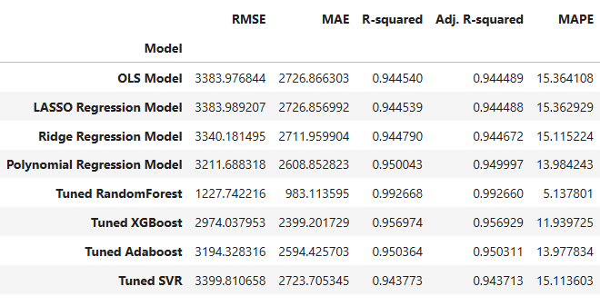
Figure 84: Model Summary

    - All Model Performance Comparison on Train data between All Models Sorted
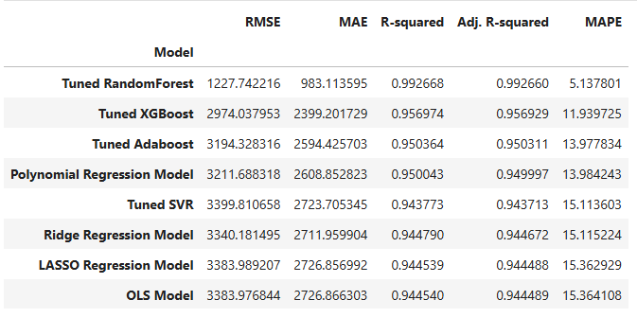
Figure 85: Model Summary

    - All Model Performance Comparison on Test data between All Models Sorted
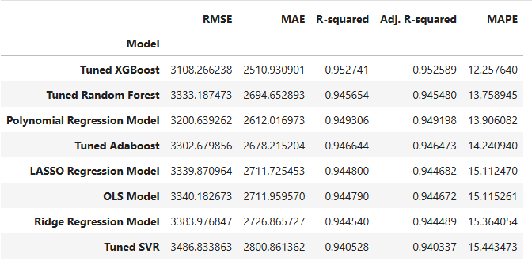
Figure 86: Model Summary
All models have given MAPE less than 15% on test data compared with Train data
This performance is in line with what we achieved with this model on the train and validation sets
So, picking top 2 models to check feature importances

12.4 Feature Importance of Tuned Random Forest Model
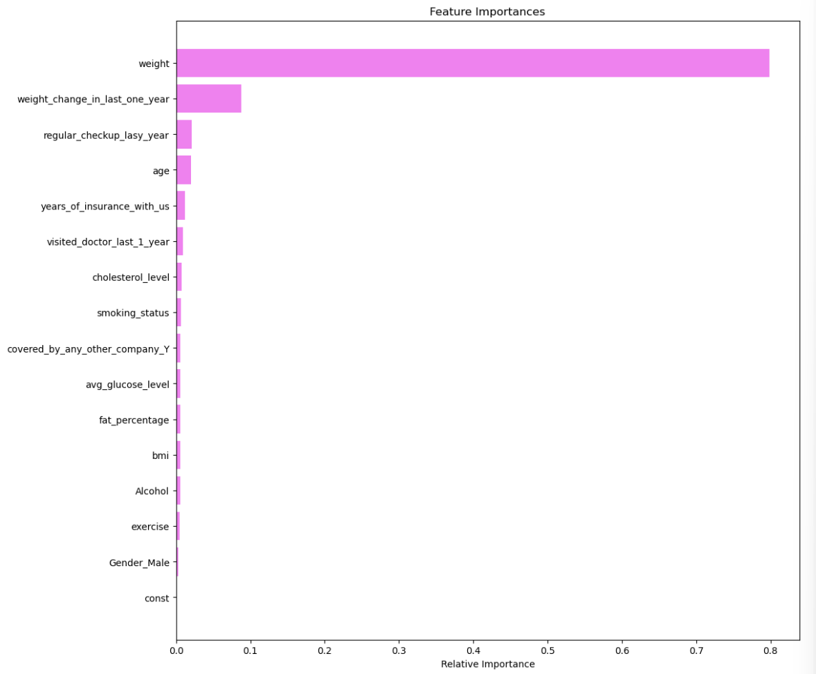

12.5 Feature Importance of Tuned XG Boost Model
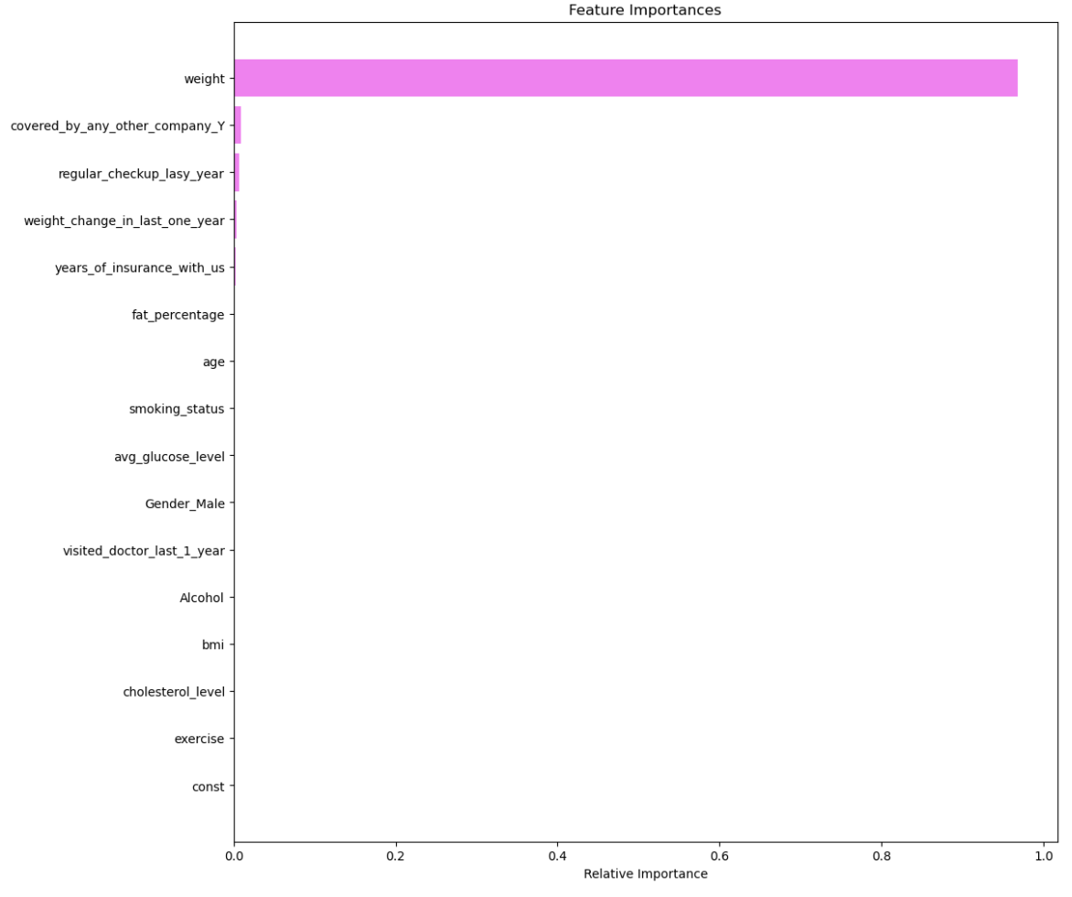

13.0 Interpretation of the Most Optimum model

Tuned XG Boost:
- The Tuned XG Boost model stands out as the most accurate and business-aligned choice in lineup. With a MAPE of just 12.26%, it offers exceptionally tight forecasting performance.
- Its R-squared value of 0.9527 confirms that it captures over 95% of the variance in the target variable, signifying strong feature.
- The model also posted the lowest RMSE and MAE, smoother performance across diverse customer profiles.
- In terms of feature behaviour, XG Boost places overwhelming emphasis on “weight”. Other features like coverage by another insurance company and regular health checkups register minor but intuitive signals, highlighting behavioural and contextual flags.

Tuned Random Forest:
- The Tuned XG Boost model stands out as the slightly lesser accurate than Tuned XG Boost model. With a MAPE of just 13.76%, it offers exceptionally tight forecasting performance.
- Its R-squared value of 0.9457 confirms that it captures over 94% of the variance in the target variable, this model still delivers highly dependable performance — just a notch below XG Boost.
- The slightly higher RMSE and MAE suggest broader prediction intervals but remain well within acceptable thresholds.
- In terms of feature behaviour, Random Forest truly shines in its clarity of feature importances. Not only does it reaffirm weight as the primary driver ~80% importance, but it also surfaces weight change in the last year as a meaningful secondary signal ~10%. Other features like checkups, age, tenure, and lifestyle indicators contribute minimally

14.0 Validation Approach
The model validation process went beyond just accuracy. We used a multi-step evaluation strategy:
1. Train-Test Split & Cross-Validation
- Data split into Train (70%) and Test (30%) for initial validation.
- For non-parametric models (Random Forest, XGBoost, etc.), Train-Validation-Test split was used to tune hyperparameters and avoid overfitting.
2. Performance Metrics
- Instead of only accuracy, we focused on metrics that reflect business needs for cost prediction:
  - R² (Coefficient of Determination): To measure variance explained by the model.
    - Tuned XGBoost achieved R² = 0.9527 (very high explanatory power).
  - MAPE (Mean Absolute Percentage Error): Business-friendly metric for forecasting errors in percentage terms.
    - Tuned XGBoost achieved MAPE = 12.26%.
  - RMSE & MAE: To assess absolute error magnitude and model stability.
3. Model Assumptions & Diagnostics (for Parametric Models)
- Multicollinearity Check: Variance Inflation Factor (VIF) calculated; variables with VIF > 5 were reviewed.
- Residual Analysis: Checked for normality (Q-Q plots), independence (residual plots), and homoscedasticity.
- Shapiro-Wilk Test: Verified normality of residuals (with approximation accepted).
4. Overfitting Control
- Hyperparameter tuning performed for non-parametric models using Grid Search and Cross-Validation.
- Compared Train vs Test performance to ensure generalization (difference within acceptable range).
5. Feature Importance Analysis
- Post-validation, analysed feature contributions using XGBoost’s feature importance scores to ensure the model’s logic aligns with domain knowledge (weight being top predictor makes sense).

Impact:
Hyperparameter tuning significantly enhanced prediction accuracy, reduced error margins, and stabilized model performance for real-world deployment.

15.0 Insights and Recommendations

15.1 Insights from Analysis
1. Weight (~95% importance)
Direction of Impact: Positive.
Interpretation: Higher body weight generally reflects higher BMI and fat %, both linked to increased cardio-metabolic risk (e.g., diabetes, heart disease).
Business Impact: Individuals with higher weight are more likely to incur higher medical expenses, leading to higher insurance costs.
2. Coverage by Another Insurance Company (~1.5% importance)
Direction of Impact: Mixed.
Interpretation: Having additional coverage could mean:
Lower actual utilization of this policy (cost dilution), OR
Higher baseline risk prompting individuals to seek multiple coverages.
Business Impact: While the direct correlation with cost is minor, these variable signals customer risk perception and can influence premium structuring or cross-sell opportunities.
3. Regular Health Checkups (~1.5% importance)
Direction of Impact: Positive.
Interpretation:
Higher checkup frequency often means active health monitoring — but in insurance pricing, it may also flag existing chronic conditions requiring continuous management.
Preventive care can lower long-term risks, but short-term insurance cost may be higher due to increased utilization.
Business Impact:
Can serve as a leading indicator for proactive care segments.
May justify wellness incentives or discounts to encourage preventive habits while managing claims.
4. Other Features (Combined ~2%)
BMI, Avg Glucose Level, Fat %, Age, Smoking, Cholesterol, Exercise, Alcohol, Weight Change, Gender, Tenure
General Impact:
These contribute marginally in isolation but can have stronger predictive power when interacting with top features (e.g., BMI + Age, Glucose + Weight).
Provide context to refine customer health profiles, underwriting, and segmentation.

15.2 Recommendations
Weight Management Programs (Top Predictor – 95% importance)
- Launch targeted wellness programs focusing on weight reduction and healthy BMI maintenance.
- Offer premium discounts or cashback incentives for customers achieving set weight or fitness targets.
- Partner with gyms, nutritionists, and wellness apps for corporate health packages.
Engagement for Low-Touch Segments (Cluster 1 – Silent Risk)
- Create outreach campaigns for customers with few/no checkups and low activity levels.
- Offer free annual screenings or preventive care vouchers to encourage early diagnosis.
- Use mobile nudges and gamified health challenges to boost participation.
Customized Plans for Dual-Coverage Holders
- For customers with coverage from another insurance company, design add-on or supplementary plans to capture additional engagement.
- Position these as “gap coverage” for risks not fully covered by their other policies.
Incentivizing Preventive Healthcare
- While frequent checkups indicate higher short-term costs, they can lower long-term claim severity.
- Introduce wellness rewards for preventive screenings, chronic condition management programs, and health coaching.
Address Data Ambiguity (Cluster 3)
- High rates of unknown smoking status and other missing lifestyle details can hide risk.
- Improve data capture at onboarding and through periodic surveys.
- Consider underwriting review or predictive risk scoring for incomplete profiles.
Promote Active Lifestyles
- Leverage step-count and exercise-level data to reward customers achieving activity milestones.
- Partner with wearable tech companies to link activity tracking with premium discounts.

